**Predictive Analytics:**

To create these predictions, we used forecasting in Tableau. Tableau uses an exponential smoothing model for its forecasting. The exponential smoothing model is advantageous for this analysis as it can handle trends and seasonality, is efficient for large data sets, and is very easy to interpret.

2020 Unemployment Predicted (before COVID-19 pandemic):

2020 Unemployment Actual:

The main goal of this prediction was to see the unemployment prediction for 2020 based on pre-COVID data. Firstly, it is impressive how well the model did in predicting the first two quarters of 2020. This is likely because the impacts of COVID-19 were not as predominant in these two quarters, so it was easier to predict. However, the model was very wrong for Q3 and Q4. This is understandable as the COVID-19 pandemic impacted the economy very harshly.

2021 Unemployment predicted:

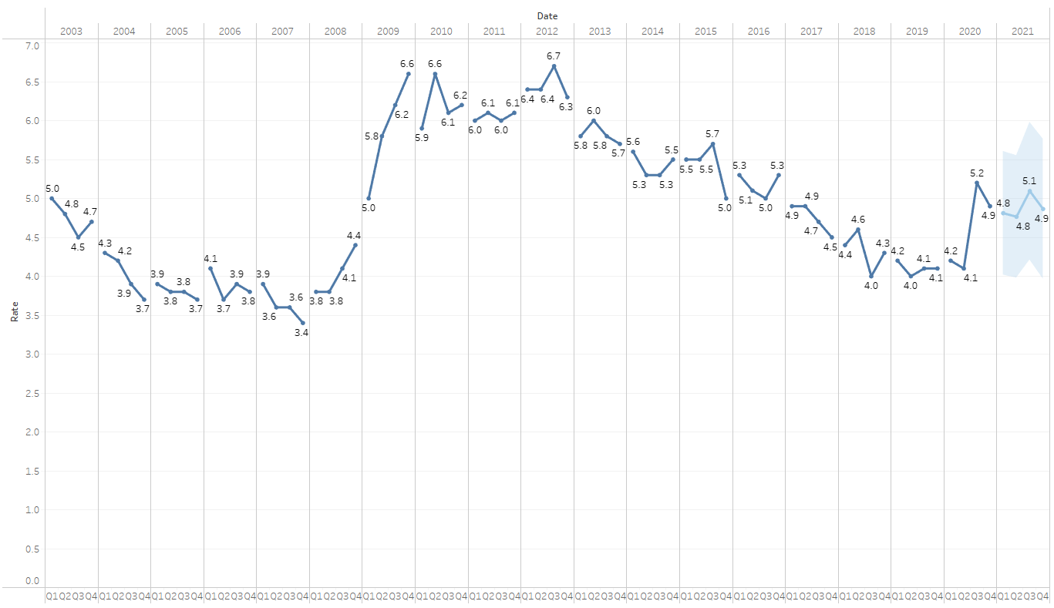

2021 Unemployment actual:

The purpose of this prediction was to make a prediction for 2021 based on data which included the data during COVID-19 in 2020. In the prediction, unemployment has small ups and downs and stays around 4.9% during the year. In the real data, unemployment decreases substantially. This prediction again represents the difficulty in predicting COVID-19 related outcomes. This shows how even with 2020 pandemic-era unemployment data to predict from, it was still very hard to predict. ­­

2023 Unemployment from Q2 predicted:

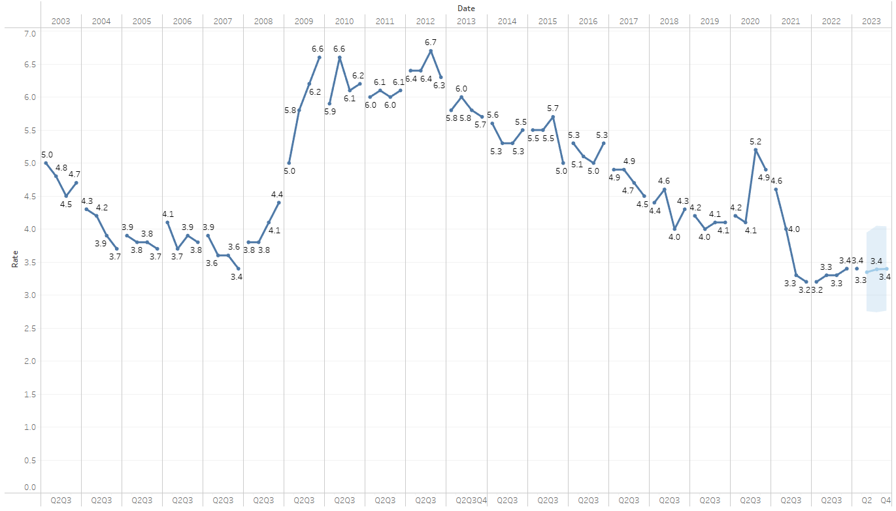

Unemployment for 2023 is predicted to stay at about 3.4% (with a small dip to 3.3% in Q2) for the rest of the year. We can be much more confident in this prediction compared to the 2020 and 2021 predictions as COVID-19 is no longer as much of a factor for unemployment, so the predictions should be more predictable. We can validate this prediction by looking at predictions during times when COVID-19 was not as large an issue as today. For example, the Q1-Q2 2020 predictions were very accurate to the real data. Similarly, the model was also quite accurate in predicting 2022 unemployment.

2020 March 25th Prediction (Level 4 Lockdown):

2020 March 25th Real Data:

The purpose of this prediction was to predict COVID-19 cases from early in the pandemic when there was very little case data available. Specifically, the prediction was started on March 26th, a day after the nationwide level 4 lockdown was enacted. As we can see by the comparison of the prediction and the real data the prediction was very inaccurate (it is also a ‘poor’ quality prediction as indicated by the metrics below the graph). This reinforces again how COVID-19 impacts, especially in the early stages, were hard to predict. One of the reasons the prediction that the prediction was made right after the lockdown was to demonstrate how little case data – and in turn, reliable case forecasts – there were when the lockdown was put in place.

2023 Cases Prediction:

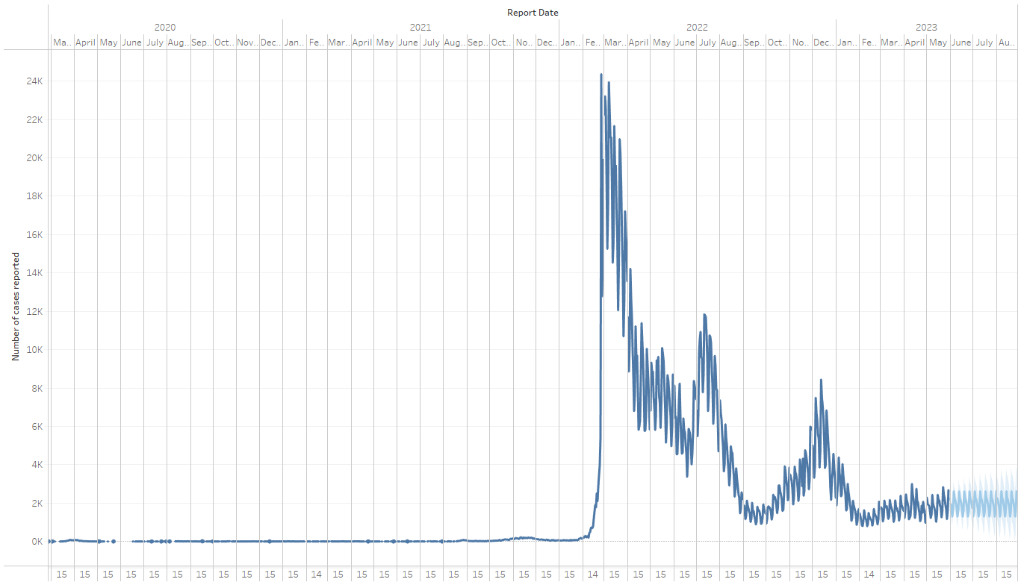

Closer view:

As shown on the graph, COVID-19 cases are expected to remain relatively the same/have the same trend for the next three months. The prediction is of ‘ok’ quality which means that it is a higher quality prediction compared to the 2020 prediction but is still not of ‘good’ quality. This shows how COVID-19 is more accurate in the present day compared to the start of the pandemic.

Overall thoughts and takeaways from health and employment predictions:

One main takeaway from these predictions is that during the pandemic, predicting the unemployment rate and COVID-19 cases was very inaccurate and unreliable. This demonstrates how disruptive the impacts of the pandemic were. In comparison, future COVID cases and unemployment predictions appear to be more reliable and accurate in comparison (however we cannot be completely sure as there is no real data to compare to). One insight from this is that as we are now better able to predict COVID-19 impacts, it means we will better be able to manage these impacts in the future. In comparison, one of the reasons that COVID-19 was very hard to manage at the beginning was because of a lack of data, and in turn, a lack of reliable predictions. Had we been able to make the same quality of predictions that we are able to make now, it is likely that the pandemic would have been able to be better managed at the start of the pandemic.

Another takeaway from this is the predictions in the future. Unemployment is predicted to stay roughly stable at around 3.4 percent throughout 2023. COVID-19 cases for the next three months (from late May 2023) are also predicted to stay similar to the levels and trends in recent months. This shows that COVID-19 impacts have mostly stabilised now, compared to the large upward and downward shifts of unemployment and cases during the pandemic. This difference in COVID-19 impacts during the pandemic and COVID-19 impacts today and into the future can be seen through relevant polls of New Zealand voters’ concerns. In 2020, COVID-19 was top of mind for many voters. Health was the most important issue for 54% of NZ voters in a Horizon Research September 2020 poll (Manch, 2020). In a 1News Kantar March 2023 poll, the cost of living was the most important issue for 48% of voters, with healthcare only being the top issue for 11% of voters (Desmarais, 2023). This again reinforces how COVID-19 impacts have mostly stabilised and are no longer as prominent as they once were.